
SUBJECT : software construction and development LAB
ASSIGNMENT NO : 5
NAME : MOIN UD DIN
ID : CU-4365-2023
SECTION:D
DEPARTMENT: SOFTWARE ENGINEERING

1. Create a Car class with attributes for model and color, and print them using
an object.

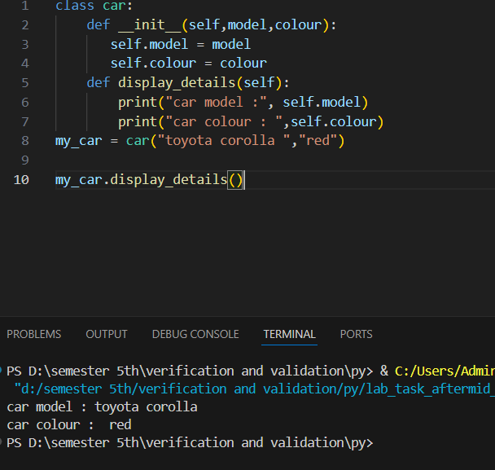

2. Calculate the area and perimeter of a rectangle using a class with length and
width attributes.
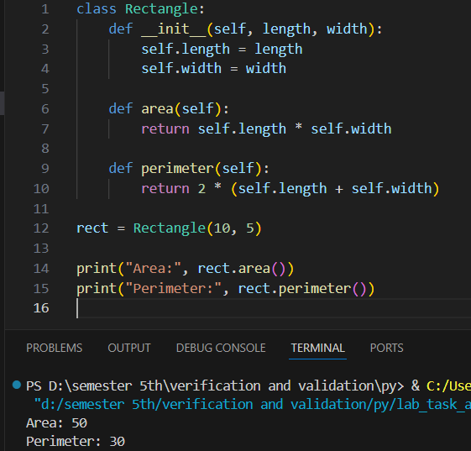

3. Create a student class that takes name and marks of 3 subjects as arguments
in constructor. Then create a method to print the average.
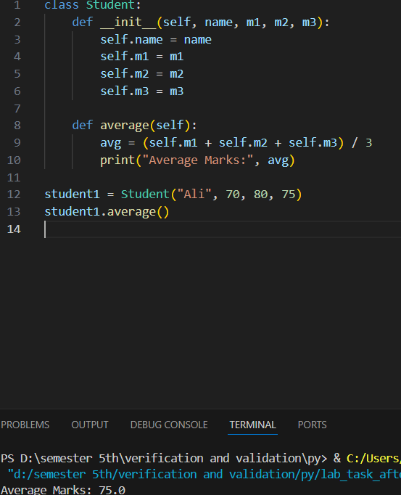

4. Check if a student has passed or failed based on their marks using a method
inside a student class.
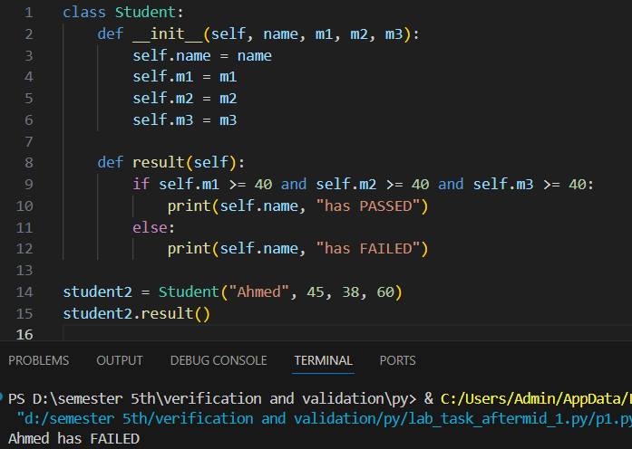

5. Create account class with 2 attributes – balance and account number.
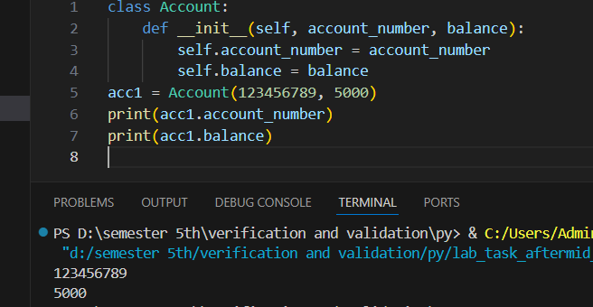

6. Create a method for debit, credit and printing balance.
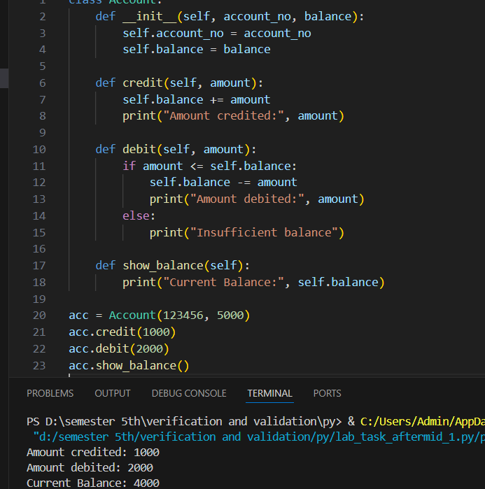

7. Define a class Employee with attributes id, name, and salary.
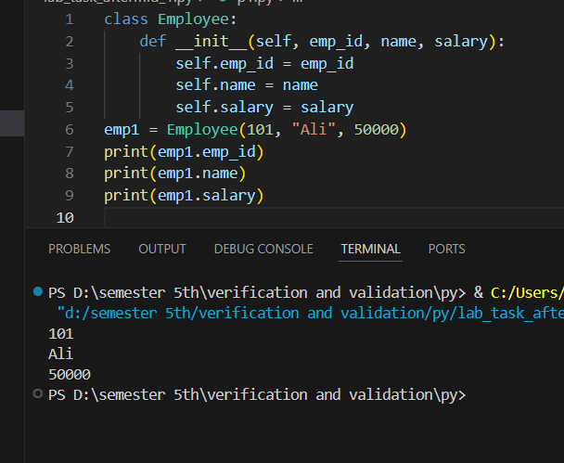

8. Define a method to calculate and display annual salary in the Employee
class.
